 | STAGE 2 – Scientific Studies (STEM)
Task Title
Collaborative Inquiry – Australian-International Model Solar Challenge
 | Teacher  Mr Loader | Year Level  Year 12 (Stage 2) | Due Date
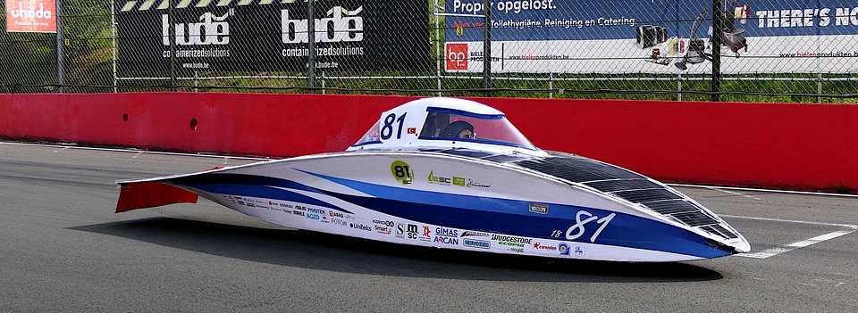

Task Introduction

Large scale renewable energy projects, such as wind and solar, are going a long way to addressing the electricity demands of our state. However transportation still poses an issue if we are to transition fully away from carbon based fuels. Therefore we need to look to different options to address our need for transportation with out petroleum
For many years the world solar car challenge has seen teams from around the world compete in a race from Darwin to Adelaide. In the last 10 years, the cruiser class has provided a look toward a future in which solar may be an option for cars for mainstream use.
https://www.worldsolarchallenge.org/the-challenge/classes/cruiser-class

The Australian-International Model Solar Challenge is a competition aimed at schools in producing small scale solar cars that mimic their larger competitors in the world solar challenge. In this task you will work collaboratively to design, construct and test a small car that runs entirely on solar power. To focus your efforts on this task you will used the regulations for the Australian-International Mode Solar Challenge as the design constraints for your car
https://www.modelsolarchallenge.com.au/

Task Requirements

The collaborative inquiry consists of two parts, therefore in order to complete this task both parts must be submitted

Collaborative Inquiry Design

In this task you will collaborate to design, construct and test a small solar car in line with the requirements for the Australian Model Solar Car Challenge. A link to these regulations can be found below.
https://www.modelsolarchallenge.com.au/sites/default/files/AIMSC%20Regulations%202021.pdf
The only modification to these regulations is that it will need to be able to run on the track that the school has, which is a little bit narrower
The design enables you to extend you science inquiry skills by:
- deconstructing a problem to determine the most appropriate method for investigation
- formulating investigable questions, hypotheses, or proposed solutions
- selecting, trialling, and using appropriate equipment, apparatus, and techniques
- identifying variables.
Science inquiry will include engineering design for the purposes of this task.
You will need to record your work on this task individually in a personal journal. The journal should include your individual deconstruction of the problem and may also include, but is not limited to:
- initial thinking, ideas, and their individual deconstruction of the problem
- planning strategies and methods trialled
- ideas or questions investigated or posed
- reflecting on progress using evidence of you own contribution to the project and supporting documentation on the group’s application of collaborative skills
- Pictorial and photographic records of experiments and progress.
- representation(s) of the data collected by the group
- analysis and interpretation of results/outcomes
- connections between results and scientific concepts
- an evaluation of the procedures and results/outcomes with suggestions for improvements
- a conclusion with justification and the consideration of possible limitations.
The personal journal should be a clear representation of your work and critical thinking.

Collaborative Inquiry Evaluation

This evaluation focusses on the effectiveness of the group’s collaborative skills in completing the design and construction of your solar car, it does not evaluate the effectiveness of the solar car itself. You will individually evaluate the strengths and weaknesses of your work as a group at different parts of the process such as:
- identifying a problem
- deconstructing the problem
- formulating an investigable question, testable hypothesis, or proposed solutions
- identifying variables
- designing and implementing appropriate procedures
- collecting data.

Assessment Conditions

- The personal journal should have a length not exceeding 12 A4 pages.
- The evaluation should take the form of a recorded presentation which should be a maximum of 5 mins.
- Both parts of this task will be submitted electronically. You must submit your full report electronically using the following naming protocols:
SACE registration number-2STU20-AT2-Collaborative Inquiry Journal
SACE registration number-2STU20-AT2-Collaborative Inquiry Evaluation

- Information on accepted file types can be found at the following link https://www.sace.sa.edu.au/teaching/resulting/online-submission/accepted-file-names-and-formats

Performance Standards for Stage 2 Scientific studies 2023

- | Investigation, Analysis, and Evaluation | Knowledge and Application
A | Critically deconstructs a problem and designs a logical, coherent, and detailed scientific investigation, using a scientific method and/or engineering design process.  Obtains, records, and represents data, using appropriate procedures, conventions, and formats accurately and highly effectively.  Systematically analyses and interprets data and evidence to formulate logical conclusions with detailed justification.  Critically and logically evaluates procedures and their effect on data.  Critically and perceptively evaluates the effectiveness of collaboration and its impact on results/outcomes. | Demonstrates deep and broad knowledge and understanding of a range of science inquiry skills and scientific concepts.  Applies science inquiry skills and scientific concepts highly effectively in new and familiar contexts.  Critically explores and understands in depth the interaction between science and society.  Communicates knowledge and understanding of scientific concepts coherently, with highly effective use of appropriate terms, conventions, and representations.
B | Logically deconstructs a problem and designs a well-considered and clear scientific investigation, using a scientific method and/or engineering design process.  Obtains, records, and represents data, using appropriate procedures, conventions, and formats mostly accurately and effectively.  Logically analyses and interprets data and evidence to formulate suitable conclusions with reasonable justification.  Logically evaluates procedures and their effect on data.  Critically evaluates the effectiveness of collaboration and its impact on results/outcomes. | Demonstrates some depth and breadth of knowledge and understanding of a range of science inquiry skills and scientific concepts.  Applies science inquiry skills and scientific concepts mostly effectively in new and familiar contexts.  Logically explores and understands in some depth the interaction between science and society.  Communicates knowledge and understanding of scientific concepts, with mostly coherent and effective use of appropriate terms, conventions, and representations.
C | Deconstructs a problem and designs a considered and generally clear scientific investigation, using a scientific method and/or engineering design process.  Obtains, records, and represents data, using generally appropriate procedures, conventions, and formats, with some errors but generally accurately and effectively.  Undertakes some analysis and interpretation of data and evidence to formulate generally appropriate conclusions with some justification.  Evaluates procedures and some of their effect on data.  Evaluates the effectiveness of collaboration and its impact on results/outcomes. | Demonstrates knowledge and understanding of a general range of science inquiry skills and scientific concepts.  Applies science inquiry skills and scientific concepts generally effectively in new or familiar contexts.  Explores and understands aspects of the interaction between science and society.  Communicates knowledge and understanding of scientific concepts, with generally effective use of appropriate terms, conventions, and representations.
D | Prepares a basic deconstruction of a problem and an outline of a scientific investigation using a scientific method and/or engineering design process.  Obtains, records, and represents data, using procedures, conventions, and formats inconsistently, with occasional accuracy and effectiveness.  Describes data and undertakes some basic interpretation to formulate a basic conclusion.  Attempts to evaluate procedures or suggest an effect on data.  Attempts to evaluate the effectiveness of collaboration and its impact on results/outcomes. | Demonstrates some basic knowledge and partial understanding of science inquiry skills and scientific concepts.  Applies some science inquiry skills and understanding of scientific concepts in familiar contexts.  Partially explores and recognises aspects of the interaction between science and society.  Communicates basic scientific information, using some appropriate terms, conventions, and/or representations.
E | Attempts a simple deconstruction of a problem and a procedure for a scientific investigation, using a scientific method and/or engineering design process.  Attempts to use some procedures and record and represent some data, with limited accuracy or effectiveness.  Attempts to describe results and/or interpret data to formulate a basic conclusion.  Acknowledges that procedures affect data.  Acknowledges the effectiveness of collaboration and its impact on results/outcomes. | Demonstrates limited recognition and awareness of science inquiry skills and/or scientific concepts.  Attempts to apply science inquiry skills and understanding of scientific concepts in familiar contexts.  Attempts to explore and identify an aspect of the interaction between science and society.  Attempts to communicate information about science.

