 | STAGE 2 – Scientific Studies (STEM)
Task Title
Science as a Human Endeavour Investigation - Recycling Renewables
 | Teacher  Mr Loader | Year Level  Stage 2 | Due Date

Task Introduction

Key to addressing the issue of climate change is a movement away from coal and gas, and a much stronger investment in renewable energy power projects, our town has been at the centre of this change. With the decommissioning of our coal fired plant and the continued construction of a number of large-scale solar and wind power projects, many with battery storage, our town is showing the what possibilities lie ahead.
However these renewable energy projects have problems the are going to face in about 25 years’ time when they are decommissioned as although the energy they produce is renewable, the resources they use to generate that power are not. Having the ability to recycle, reclaim, repurpose and reuse the resources is key to ensure we can sustain this type of power generation long term. However as it currently stands, many of these renewable energy technologies can be difficult to reuse in this way, and this is the focus of this investigation.
As a starting point for this investigation you may look at the article below which investigates the issue.
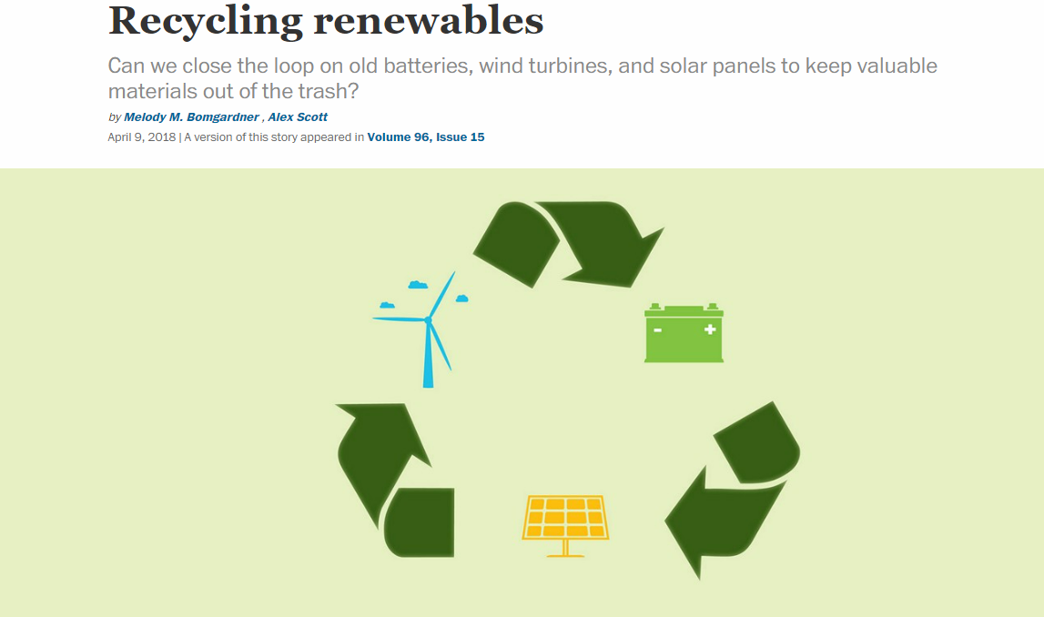
https://cen.acs.org/energy/renewables/Recycling-renewables/96/i15
Bomgardener, M and Scott, A (2018)

Task Requirements

This task has a focus on science as a human endeavour; how science interacts with society.

Select and explore a recent discovery, innovation, issue, or advancement linked to recycling in the renewable energy sector. Examples could come from wind power, solar power, or battery storage. Use one or more of the key concepts of science as a human endeavour to develop a focus question for your investigation. Make your question quite specific to enable you to analyse information in depth.
Select, analyse and synthesise information from different sources to:
- explain the science relevant to the focus of your investigation
- show its connections to science as a human endeavour

Prepare a scientific report, which must include the use of scientific terminology and:
- an introduction to identify the focus of the investigation and the key concept(s) of science as a human endeavour that it links to
- relative scientific concepts and background
- an explanation of how the focus of the investigation illustrates the interaction between science and society, including a discussion of the potential impact of the focus of the investigation, e.g. further development, effect on quality of life, environmental implications, economic impact, intrinsic interest
- a conclusion that summarises the connection between your topic and the selected key concept(s) of science as a human endeavour
- citations and referencing.

SHE Concepts
Taken from the SACE Scientific Studies Subject Outline
Communication and Collaboration
- Science is a global enterprise that relies on clear communication, international conventions, and review and verification of results.
- Collaboration between scientists, governments, and other agencies is often required in scientific research and enterprise.
Development
- Development of complex scientific models and/or theories often requires a wide range of evidence from many sources and across disciplines.
- New technologies improve the efficiency of scientific procedures, practices, and data collection and analysis. This can reveal new evidence that may modify or replace models, theories, and processes.

Influence
- Advances in scientific understanding in one field can influence and be influenced by other areas of science, technology, engineering, and mathematics.
- The acceptance and use of scientific knowledge can be influenced by social, economic, cultural, and ethical considerations.
Application and Limitation
- Scientific knowledge, understanding, and inquiry can enable scientists to develop solutions, make discoveries, design action for sustainability, evaluate economic, social, cultural, and environmental impacts, offer valid explanations, and make reliable predictions.
- The use of scientific knowledge may have beneficial or unexpected consequences; this requires monitoring, assessment, and evaluation of risk, and provides opportunities for innovation.
- Science informs public debate and is in turn influenced by public debate; at times, there may be complex, unanticipated variables or insufficient data that may limit possible conclusions.

Assessment Conditions

- The word limit is 1500 words (if written) or 10 minutes if in oral form (or equivalent in multimodal form).
- The final report will be submitted electronically. You must submit your full report electronically using the following naming protocol:
SACE registration number-2STU20-AT1-SHE Task
- If you are doing an oral presentation it will be necessary to record it for assessment and moderation.

Performance Standards for Stage 2 Scientific studies 2023

- | Investigation, Analysis, and Evaluation | Knowledge and Application
A | Critically deconstructs a problem and designs a logical, coherent, and detailed scientific investigation, using a scientific method and/or engineering design process.  Obtains, records, and represents data, using appropriate procedures, conventions, and formats accurately and highly effectively.  Systematically analyses and interprets data and evidence to formulate logical conclusions with detailed justification.  Critically and logically evaluates procedures and their effect on data.  Critically and perceptively evaluates the effectiveness of collaboration and its impact on results/outcomes. | Demonstrates deep and broad knowledge and understanding of a range of science inquiry skills and scientific concepts.  Applies science inquiry skills and scientific concepts highly effectively in new and familiar contexts.  Critically explores and understands in depth the interaction between science and society.  Communicates knowledge and understanding of scientific concepts coherently, with highly effective use of appropriate terms, conventions, and representations.
B | Logically deconstructs a problem and designs a well-considered and clear scientific investigation, using a scientific method and/or engineering design process.  Obtains, records, and represents data, using appropriate procedures, conventions, and formats mostly accurately and effectively.  Logically analyses and interprets data and evidence to formulate suitable conclusions with reasonable justification.  Logically evaluates procedures and their effect on data.  Critically evaluates the effectiveness of collaboration and its impact on results/outcomes. | Demonstrates some depth and breadth of knowledge and understanding of a range of science inquiry skills and scientific concepts.  Applies science inquiry skills and scientific concepts mostly effectively in new and familiar contexts.  Logically explores and understands in some depth the interaction between science and society.  Communicates knowledge and understanding of scientific concepts, with mostly coherent and effective use of appropriate terms, conventions, and representations.
C | Deconstructs a problem and designs a considered and generally clear scientific investigation, using a scientific method and/or engineering design process.  Obtains, records, and represents data, using generally appropriate procedures, conventions, and formats, with some errors but generally accurately and effectively.  Undertakes some analysis and interpretation of data and evidence to formulate generally appropriate conclusions with some justification.  Evaluates procedures and some of their effect on data.  Evaluates the effectiveness of collaboration and its impact on results/outcomes. | Demonstrates knowledge and understanding of a general range of science inquiry skills and scientific concepts.  Applies science inquiry skills and scientific concepts generally effectively in new or familiar contexts.  Explores and understands aspects of the interaction between science and society.  Communicates knowledge and understanding of scientific concepts, with generally effective use of appropriate terms, conventions, and representations.
D | Prepares a basic deconstruction of a problem and an outline of a scientific investigation using a scientific method and/or engineering design process.  Obtains, records, and represents data, using procedures, conventions, and formats inconsistently, with occasional accuracy and effectiveness.  Describes data and undertakes some basic interpretation to formulate a basic conclusion.  Attempts to evaluate procedures or suggest an effect on data.  Attempts to evaluate the effectiveness of collaboration and its impact on results/outcomes. | Demonstrates some basic knowledge and partial understanding of science inquiry skills and scientific concepts.  Applies some science inquiry skills and understanding of scientific concepts in familiar contexts.  Partially explores and recognises aspects of the interaction between science and society.  Communicates basic scientific information, using some appropriate terms, conventions, and/or representations.
E | Attempts a simple deconstruction of a problem and a procedure for a scientific investigation, using a scientific method and/or engineering design process.  Attempts to use some procedures and record and represent some data, with limited accuracy or effectiveness.  Attempts to describe results and/or interpret data to formulate a basic conclusion.  Acknowledges that procedures affect data.  Acknowledges the effectiveness of collaboration and its impact on results/outcomes. | Demonstrates limited recognition and awareness of science inquiry skills and/or scientific concepts.  Attempts to apply science inquiry skills and understanding of scientific concepts in familiar contexts.  Attempts to explore and identify an aspect of the interaction between science and society.  Attempts to communicate information about science.

