 | STAGE 2 – Scientific Studies (STEM)
Task Title
Science Inquiry Skills Task – Bungala Solar Farm Educational Resources
 | Teacher  Mr Loader | Year Level  Year 12 (Stage 2) | Due Date
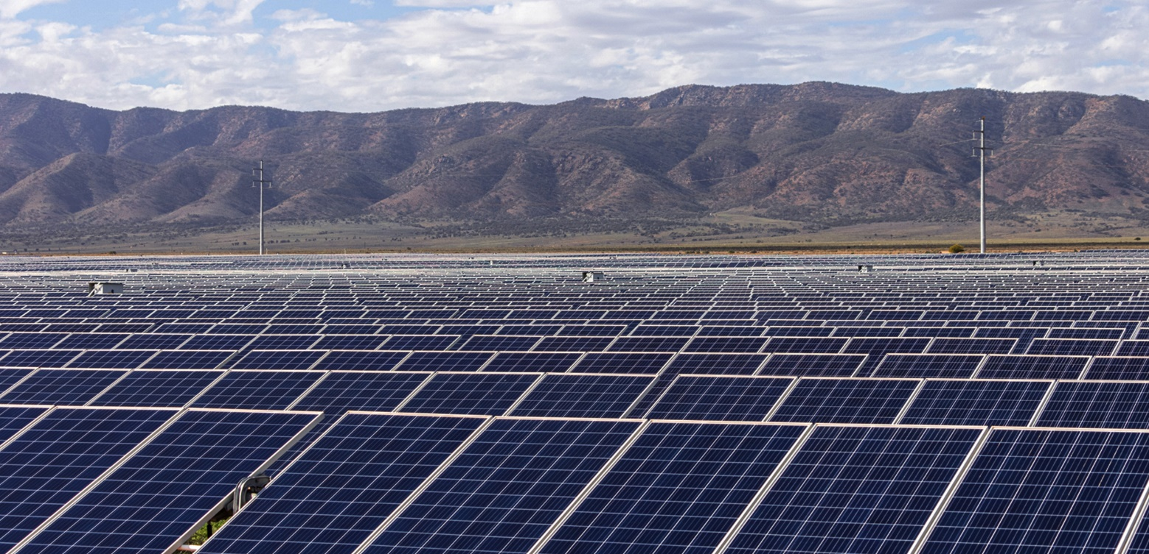

Task Introduction

The Bungala Solar Farm, which is owned and operated by Enel Green Power, was the first grid-scale solar project to be constructed in South Australia and remains to be one of Australia’s largest solar farms, consisting of 840 000 solar panels. Enel Green Power has more than 1300 renewable energy projects around the world with almost 65000 MW of installed capacity. Having partnered with the STEM Centre for a number of years they are clear in their desire to work with the communities that surround their installations, and are keen to get school groups to visit the farm to get a better understanding of solar power and how it all works.
This however poses some challenges including the following
- Due to dangers at the site such as high voltages, sensitive equipment, and wildlife such as snakes it is generally not appropriate for most school groups to get out of the bus whilst in the array therefore they cannot see it up close
- Even if the array was safe to observe closely, the systems cannot be observed in operation as they move very slowly.
- Other than just observing the array, and a short talk being given, there is not much to do out at the solar farm that is interactive for school groups
This task aims to address these issues by producing educational resources that will help school students engage with renewable power generation and the technology at the Bungala Solar Farm.

Task Requirements

In this task you will be using the engineering design process to create an interactive display aimed at educating school groups about the operation of the solar farm. In completing this task you will have to include the following aspects
- A deconstruction of the problem by particularly in relation to how the solar farm operates, this can be done during a visit to the farm that will be organised
- Documentation of the development of your prototype including photos, sketches etc
- A poster or presentation that explains your prototype and how it links to the operation of the solar farm

Assessment Conditions

- The maximum length of this task is 4 x A4 pages or equivalent in multimodal form.
- The final report will be submitted electronically. You must submit your full report electronically using the following naming protocol:

SACE registration number-2STU20-AT1-Solar Farm Resources

- If you are doing an oral presentation it will be necessary to record it for assessment and moderation.

Performance Standards for Stage 2 Scientific studies 2023

- | Investigation, Analysis, and Evaluation | Knowledge and Application
A | Critically deconstructs a problem and designs a logical, coherent, and detailed scientific investigation, using a scientific method and/or engineering design process.  Obtains, records, and represents data, using appropriate procedures, conventions, and formats accurately and highly effectively.  Systematically analyses and interprets data and evidence to formulate logical conclusions with detailed justification.  Critically and logically evaluates procedures and their effect on data.  Critically and perceptively evaluates the effectiveness of collaboration and its impact on results/outcomes. | Demonstrates deep and broad knowledge and understanding of a range of science inquiry skills and scientific concepts.  Applies science inquiry skills and scientific concepts highly effectively in new and familiar contexts.  Critically explores and understands in depth the interaction between science and society.  Communicates knowledge and understanding of scientific concepts coherently, with highly effective use of appropriate terms, conventions, and representations.
B | Logically deconstructs a problem and designs a well-considered and clear scientific investigation, using a scientific method and/or engineering design process.  Obtains, records, and represents data, using appropriate procedures, conventions, and formats mostly accurately and effectively.  Logically analyses and interprets data and evidence to formulate suitable conclusions with reasonable justification.  Logically evaluates procedures and their effect on data.  Critically evaluates the effectiveness of collaboration and its impact on results/outcomes. | Demonstrates some depth and breadth of knowledge and understanding of a range of science inquiry skills and scientific concepts.  Applies science inquiry skills and scientific concepts mostly effectively in new and familiar contexts.  Logically explores and understands in some depth the interaction between science and society.  Communicates knowledge and understanding of scientific concepts, with mostly coherent and effective use of appropriate terms, conventions, and representations.
C | Deconstructs a problem and designs a considered and generally clear scientific investigation, using a scientific method and/or engineering design process.  Obtains, records, and represents data, using generally appropriate procedures, conventions, and formats, with some errors but generally accurately and effectively.  Undertakes some analysis and interpretation of data and evidence to formulate generally appropriate conclusions with some justification.  Evaluates procedures and some of their effect on data.  Evaluates the effectiveness of collaboration and its impact on results/outcomes. | Demonstrates knowledge and understanding of a general range of science inquiry skills and scientific concepts.  Applies science inquiry skills and scientific concepts generally effectively in new or familiar contexts.  Explores and understands aspects of the interaction between science and society.  Communicates knowledge and understanding of scientific concepts, with generally effective use of appropriate terms, conventions, and representations.
D | Prepares a basic deconstruction of a problem and an outline of a scientific investigation using a scientific method and/or engineering design process.  Obtains, records, and represents data, using procedures, conventions, and formats inconsistently, with occasional accuracy and effectiveness.  Describes data and undertakes some basic interpretation to formulate a basic conclusion.  Attempts to evaluate procedures or suggest an effect on data.  Attempts to evaluate the effectiveness of collaboration and its impact on results/outcomes. | Demonstrates some basic knowledge and partial understanding of science inquiry skills and scientific concepts.  Applies some science inquiry skills and understanding of scientific concepts in familiar contexts.  Partially explores and recognises aspects of the interaction between science and society.  Communicates basic scientific information, using some appropriate terms, conventions, and/or representations.
E | Attempts a simple deconstruction of a problem and a procedure for a scientific investigation, using a scientific method and/or engineering design process.  Attempts to use some procedures and record and represent some data, with limited accuracy or effectiveness.  Attempts to describe results and/or interpret data to formulate a basic conclusion.  Acknowledges that procedures affect data.  Acknowledges the effectiveness of collaboration and its impact on results/outcomes. | Demonstrates limited recognition and awareness of science inquiry skills and/or scientific concepts.  Attempts to apply science inquiry skills and understanding of scientific concepts in familiar contexts.  Attempts to explore and identify an aspect of the interaction between science and society.  Attempts to communicate information about science.

