 | STAGE 2 – Scientific Studies (STEM)
Task Title
Investigating Sustainable Materials for Wind Turbine Blades
 | Teacher  Mr Loader | Year Level  Year 12 (Stage 2) | Due Date
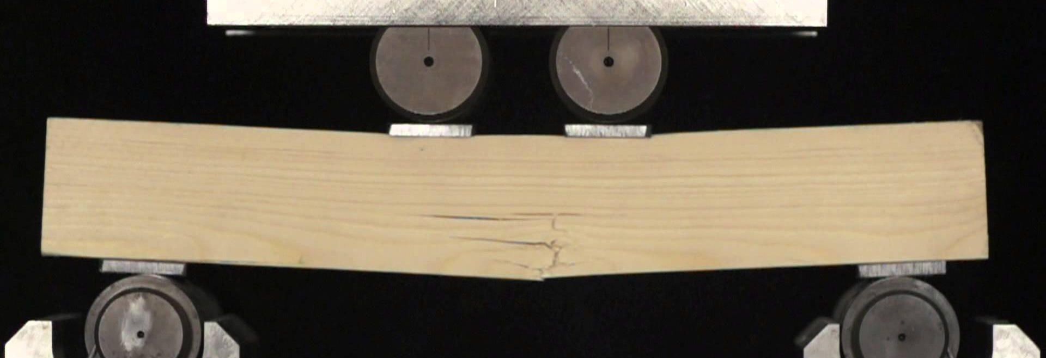

Task Introduction

Wind turbines are an incredibly important part of our sustainable energy future, and are effective in converting an abundant natural resource into energy. However like all sustainable energy developments, they use a great deal of resources in the construction phase, and only have an operating life of about 25 years. At the end of their operating life there are some resources in the turbines that can be reclaimed and reused, but one noticeable exception are the blades, which are made of fibreglass and are consequently put into landfill once finished with, creating a significant waste problem.
Wood is actively being investigated as a possible replacement for fibreglass in the wind turbine blades, however there is a huge variety of the types of wood available and their properties. Materials testing is a branch of engineering that looks at isolating and testing different properties related to different materials. This can involve destructive testing such as stretching (tensile strength), squashing (compressive strength) or bending (flexural strength) until the sample breaks, or non-destructive testing. By performing such testing we can identify suitable substitutes for traditional materials or look at testing new materials to see if they are improvements on those we already have.
In relation to wind turbine blades we are not necessarily looking at stretching or squashing the blades, given their length and the fact that the wind is pushing against them, flexural strength is a strong consideration for these blades. Many of the machines used to perform this analysis are very expensive however we are able to simulate such machines with relatively inexpensive materials and measurement devices coupled with some 3D printed parts that have be made available complements of the University of NSW.

Task Requirements
In this task you will investigate the effectiveness of different types of wood as wind turbine blades, this will be achieving by comparing the mechanical properties of different woods to that of fibreglass using materials testing methodologies. The question you are trying to answer in this investigation is:
What type of wood may be a suitable replacement for fibreglass in the construction of more sustainable wind turbine blades?
There are a number of woods you will test against your fibreglass sample, therefore you will collect the data collaboratively, sharing your results with others in the class. To ensure consistency in the data collection you will follow the same procedure which is outlined below.
You must produce an individual report that contains the following parts
The report must include:
- introduction, providing the basis for the investigation
- hypothesis with variables
- summary of the design of the investigation or model(s)
- results of the practical investigation and analysis of the results, including identification of trends and linking results to relevant discipline knowledge
- evaluation of the method/model(s) used
- identification of sources of uncertainty
- conclusion with justification and consideration of the limitations of the investigation
- citations and referencing.

Assessment Conditions

- This task has a maximum length of 4 x A4 pages.
- The final report will be submitted electronically. You must submit your full report electronically using the following naming protocol:

SACE registration number-2STU20-AT1-Blade Materials

- If you are doing an oral presentation it will be necessary to record it for assessment and moderation.

Experimental Method

An example of how this testing rig will be used, and the results analysed can be found at the link below
https://www.youtube.com/watch?v=te0Wwf7Dxj4
Jig and Sample Set up
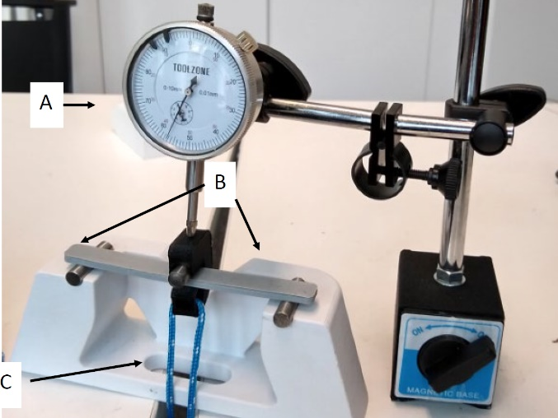
- Place the Bending Test jig in between 2 tables (to allow space for the ruler and weights to hang), ensuring the jig is stable (using blu-tac to stick it down, since the jig is fairly light).
- Place a sample on the jig. Centre the sample between the bottom support pins.
- Slide the top loading pin onto the sample, centring it between the bottom supports. Thread the string through the bottom of the jig.
- Position your dial indicator over the top of the load pin as shown, you will need to make sure that the plunger is compressed so that the dial indicator reads approximately 5 mm
Density Calculations
- Calculate volume of each sample in cubic centimetres, Vernier calipers should be used to take precise measurements.
- Weigh each sample in grams using electronic scales.
- Calculated the density of each sample in grams per cubic centimetre
Mechanical Property Tests
- Add slotted masses to the rope until you have achieved a deflection of 3mm.
- Record the weight required to achieve that deflection.
- Use this to calculate the elastic modulus
- Continue adding weights, 100 grams at a time until the sample fractures
- Record the weight and use this to calculate the flexural stress
- Repeat steps 1 to 5 until all the materials are tested
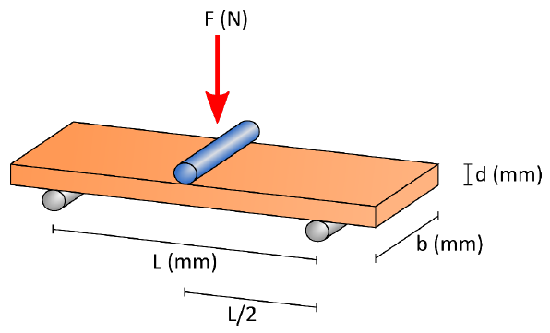
Calculations
$$Elastic Modulus \left(MPa\right)=\frac{L^{3}m}{4bd^{3}} Flexural Stress (\frac{N}{mm^{2}})=\frac{3FL}{2bd^{2}}$$
$$F=Force \left(N\right)=0.00981×mass added (g)$$
$$m=straight line load deflection=\frac{F}{3} (3 used as 3mm deflection)$$
Results
Your results should be recorded in an appropriate table with supporting graphs for density corrected elastic modulus and flexural stress.

Performance Standards for Stage 2 Scientific studies 2023

- | Investigation, Analysis, and Evaluation | Knowledge and Application
A | Critically deconstructs a problem and designs a logical, coherent, and detailed scientific investigation, using a scientific method and/or engineering design process.  Obtains, records, and represents data, using appropriate procedures, conventions, and formats accurately and highly effectively.  Systematically analyses and interprets data and evidence to formulate logical conclusions with detailed justification.  Critically and logically evaluates procedures and their effect on data.  Critically and perceptively evaluates the effectiveness of collaboration and its impact on results/outcomes. | Demonstrates deep and broad knowledge and understanding of a range of science inquiry skills and scientific concepts.  Applies science inquiry skills and scientific concepts highly effectively in new and familiar contexts.  Critically explores and understands in depth the interaction between science and society.  Communicates knowledge and understanding of scientific concepts coherently, with highly effective use of appropriate terms, conventions, and representations.
B | Logically deconstructs a problem and designs a well-considered and clear scientific investigation, using a scientific method and/or engineering design process.  Obtains, records, and represents data, using appropriate procedures, conventions, and formats mostly accurately and effectively.  Logically analyses and interprets data and evidence to formulate suitable conclusions with reasonable justification.  Logically evaluates procedures and their effect on data.  Critically evaluates the effectiveness of collaboration and its impact on results/outcomes. | Demonstrates some depth and breadth of knowledge and understanding of a range of science inquiry skills and scientific concepts.  Applies science inquiry skills and scientific concepts mostly effectively in new and familiar contexts.  Logically explores and understands in some depth the interaction between science and society.  Communicates knowledge and understanding of scientific concepts, with mostly coherent and effective use of appropriate terms, conventions, and representations.
C | Deconstructs a problem and designs a considered and generally clear scientific investigation, using a scientific method and/or engineering design process.  Obtains, records, and represents data, using generally appropriate procedures, conventions, and formats, with some errors but generally accurately and effectively.  Undertakes some analysis and interpretation of data and evidence to formulate generally appropriate conclusions with some justification.  Evaluates procedures and some of their effect on data.  Evaluates the effectiveness of collaboration and its impact on results/outcomes. | Demonstrates knowledge and understanding of a general range of science inquiry skills and scientific concepts.  Applies science inquiry skills and scientific concepts generally effectively in new or familiar contexts.  Explores and understands aspects of the interaction between science and society.  Communicates knowledge and understanding of scientific concepts, with generally effective use of appropriate terms, conventions, and representations.
D | Prepares a basic deconstruction of a problem and an outline of a scientific investigation using a scientific method and/or engineering design process.  Obtains, records, and represents data, using procedures, conventions, and formats inconsistently, with occasional accuracy and effectiveness.  Describes data and undertakes some basic interpretation to formulate a basic conclusion.  Attempts to evaluate procedures or suggest an effect on data.  Attempts to evaluate the effectiveness of collaboration and its impact on results/outcomes. | Demonstrates some basic knowledge and partial understanding of science inquiry skills and scientific concepts.  Applies some science inquiry skills and understanding of scientific concepts in familiar contexts.  Partially explores and recognises aspects of the interaction between science and society.  Communicates basic scientific information, using some appropriate terms, conventions, and/or representations.
E | Attempts a simple deconstruction of a problem and a procedure for a scientific investigation, using a scientific method and/or engineering design process.  Attempts to use some procedures and record and represent some data, with limited accuracy or effectiveness.  Attempts to describe results and/or interpret data to formulate a basic conclusion.  Acknowledges that procedures affect data.  Acknowledges the effectiveness of collaboration and its impact on results/outcomes. | Demonstrates limited recognition and awareness of science inquiry skills and/or scientific concepts.  Attempts to apply science inquiry skills and understanding of scientific concepts in familiar contexts.  Attempts to explore and identify an aspect of the interaction between science and society.  Attempts to communicate information about science.

