 | STAGE 2 – Scientific Studies (STEM)
Task Title
Science Inquiry Skills Task – Wind Farm Siting
 | Teacher  Mr Loader | Year Level  Year 12 (Stage 2) | Due Date
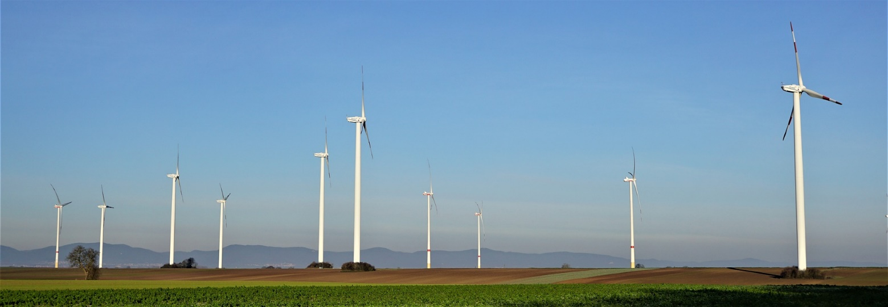

Task Introduction

South Australia is global leader when it comes to renewable power generation. For many years the majority of our electricity generation has come from renewable resources. By far the largest contributor to this has been wind power. In the Port Augusta region, we have had wind turbines installed at the Port Augusta Renewable Energy Park, and also at Lincoln Gap.
The first consideration in any wind farm development is where to place it. There are many factors to consider in such a choice including but not limited to
- Meteorological factors – Are the weather conditions appropriate and consistent enough?
- Geographical factors – is the land suitable for the construction of turbines? Are there any factors that will hinder their operation?
- Environmental factors – How will this development impact flora and fauna in the area?
- Economic factors – Will this be profitable for the company? How will economically impact the local community? How may this impact the current uses for that land?
- Human factors – What are people’s perceptions? How may the development be impacted by local, state or federal laws?
It is often a requirement of developers to commission studies into potential sites to collect data so that appropriate choices can be made about whether a project should proceed. Any choice should weigh up the potential positives and negatives of each site.

Task Requirements

In this task you will be presented with two case studies on potential wind farm locations. There is a diverse range of data sets for each site that you will need to look at and analyse, examples of the types of data sets are outlined below.
- Project scope | - Elevation and land use
- Wind speed | - Bird and bat Species in the area
- Transmission line considerations | - Wetlands and protected areas
- Local laws | - Visual/aesthetic considerations
- Property values | - Community opinion

For this task the data sets can be obtained from the for the Microsoft Teams group for this class

In this task you will assume the role of a consultant working for the parent company of the two proposed wind farms. The parent company can currently only financially support the development of one of these sites and your role with the company is to determine which of the two proposed projects should be the one to proceed. This will require comparing and contrasting data from the two sites and a making a choice based not just on which one produces the most economic benefit, but also the one which is likely to have the lowest environmental cost. You will prepare a report or presentation for the company, using supporting evidence from the case studies, in order to outline and justify your choice. In completing this report or presentation it will be useful to reflect on the SHE concepts as these look at how scientific evidence and understanding can inform choices.

SHE Concepts
Taken from the SACE Scientific Studies Subject Outline
Communication and Collaboration
- Science is a global enterprise that relies on clear communication, international conventions, and review and verification of results.
- Collaboration between scientists, governments, and other agencies is often required in scientific research and enterprise.
Development
- Development of complex scientific models and/or theories often requires a wide range of evidence from many sources and across disciplines.
- New technologies improve the efficiency of scientific procedures, practices, and data collection and analysis. This can reveal new evidence that may modify or replace models, theories, and processes.

Influence
- Advances in scientific understanding in one field can influence and be influenced by other areas of science, technology, engineering, and mathematics.
- The acceptance and use of scientific knowledge can be influenced by social, economic, cultural, and ethical considerations.
Application and Limitation
- Scientific knowledge, understanding, and inquiry can enable scientists to develop solutions, make discoveries, design action for sustainability, evaluate economic, social, cultural, and environmental impacts, offer valid explanations, and make reliable predictions.
- The use of scientific knowledge may have beneficial or unexpected consequences; this requires monitoring, assessment, and evaluation of risk, and provides opportunities for innovation.
- Science informs public debate and is in turn influenced by public debate; at times, there may be complex, unanticipated variables or insufficient data that may limit possible conclusions.

Assessment Conditions

- The task should be a maximum of 4 x A4 pages or the equivalent in multimodal form.
- The final report will be submitted electronically. You must submit your full report electronically using the following naming protocol:

SACE registration number-2STU20-AT1-Wind Farm Siting

- If you are doing an oral presentation it will be necessary to record it for assessment and moderation.

Performance Standards for Stage 2 Scientific studies 2023

- | Investigation, Analysis, and Evaluation | Knowledge and Application
A | Critically deconstructs a problem and designs a logical, coherent, and detailed scientific investigation, using a scientific method and/or engineering design process.  Obtains, records, and represents data, using appropriate procedures, conventions, and formats accurately and highly effectively.  Systematically analyses and interprets data and evidence to formulate logical conclusions with detailed justification.  Critically and logically evaluates procedures and their effect on data.  Critically and perceptively evaluates the effectiveness of collaboration and its impact on results/outcomes. | Demonstrates deep and broad knowledge and understanding of a range of science inquiry skills and scientific concepts.  Applies science inquiry skills and scientific concepts highly effectively in new and familiar contexts.  Critically explores and understands in depth the interaction between science and society.  Communicates knowledge and understanding of scientific concepts coherently, with highly effective use of appropriate terms, conventions, and representations.
B | Logically deconstructs a problem and designs a well-considered and clear scientific investigation, using a scientific method and/or engineering design process.  Obtains, records, and represents data, using appropriate procedures, conventions, and formats mostly accurately and effectively.  Logically analyses and interprets data and evidence to formulate suitable conclusions with reasonable justification.  Logically evaluates procedures and their effect on data.  Critically evaluates the effectiveness of collaboration and its impact on results/outcomes. | Demonstrates some depth and breadth of knowledge and understanding of a range of science inquiry skills and scientific concepts.  Applies science inquiry skills and scientific concepts mostly effectively in new and familiar contexts.  Logically explores and understands in some depth the interaction between science and society.  Communicates knowledge and understanding of scientific concepts, with mostly coherent and effective use of appropriate terms, conventions, and representations.
C | Deconstructs a problem and designs a considered and generally clear scientific investigation, using a scientific method and/or engineering design process.  Obtains, records, and represents data, using generally appropriate procedures, conventions, and formats, with some errors but generally accurately and effectively.  Undertakes some analysis and interpretation of data and evidence to formulate generally appropriate conclusions with some justification.  Evaluates procedures and some of their effect on data.  Evaluates the effectiveness of collaboration and its impact on results/outcomes. | Demonstrates knowledge and understanding of a general range of science inquiry skills and scientific concepts.  Applies science inquiry skills and scientific concepts generally effectively in new or familiar contexts.  Explores and understands aspects of the interaction between science and society.  Communicates knowledge and understanding of scientific concepts, with generally effective use of appropriate terms, conventions, and representations.
D | Prepares a basic deconstruction of a problem and an outline of a scientific investigation using a scientific method and/or engineering design process.  Obtains, records, and represents data, using procedures, conventions, and formats inconsistently, with occasional accuracy and effectiveness.  Describes data and undertakes some basic interpretation to formulate a basic conclusion.  Attempts to evaluate procedures or suggest an effect on data.  Attempts to evaluate the effectiveness of collaboration and its impact on results/outcomes. | Demonstrates some basic knowledge and partial understanding of science inquiry skills and scientific concepts.  Applies some science inquiry skills and understanding of scientific concepts in familiar contexts.  Partially explores and recognises aspects of the interaction between science and society.  Communicates basic scientific information, using some appropriate terms, conventions, and/or representations.
E | Attempts a simple deconstruction of a problem and a procedure for a scientific investigation, using a scientific method and/or engineering design process.  Attempts to use some procedures and record and represent some data, with limited accuracy or effectiveness.  Attempts to describe results and/or interpret data to formulate a basic conclusion.  Acknowledges that procedures affect data.  Acknowledges the effectiveness of collaboration and its impact on results/outcomes. | Demonstrates limited recognition and awareness of science inquiry skills and/or scientific concepts.  Attempts to apply science inquiry skills and understanding of scientific concepts in familiar contexts.  Attempts to explore and identify an aspect of the interaction between science and society.  Attempts to communicate information about science.

