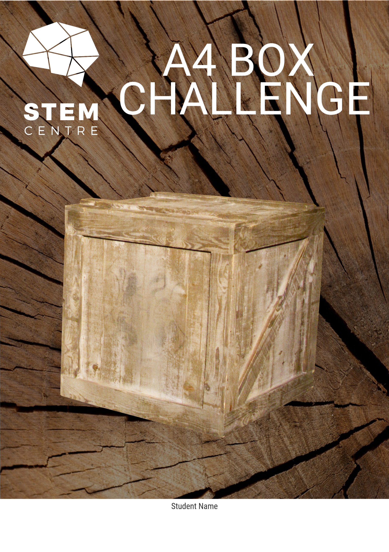
Contents
Resources 3
Basic Information 4
The Challenge 5
Project Information 6
Prototype Development 7
Final Solution Selection 10
Testing and Analysis of Volume 11
Testing and Analysis of Material Wastage 12
Analysis of the Designs of Others 13
Group Work Reflection 14
Task Quality Reflection 15
Project Timeline – Gantt Chart 16
Characteristics of Effective Collaboration 17
Spare Pages 18

Resources

Additional resources to help with the completion of this task can be found at the Port Augusta Secondary School STEM centre website. This includes instructional videos on various parts of the task and also links to download the CAD software.

http://stematpass.weebly.com

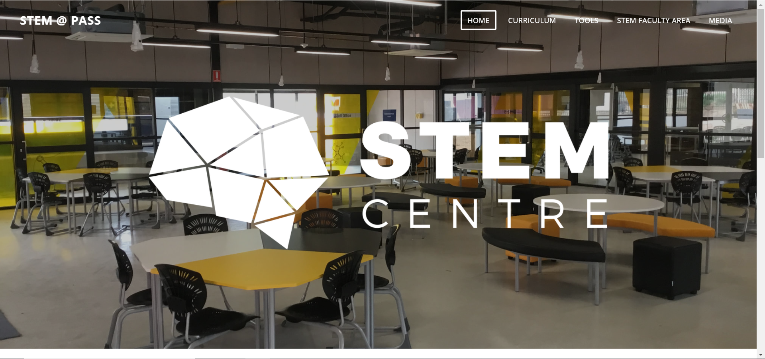

The link to the resources is under curriculum and then Laser Cut Box Challenge.
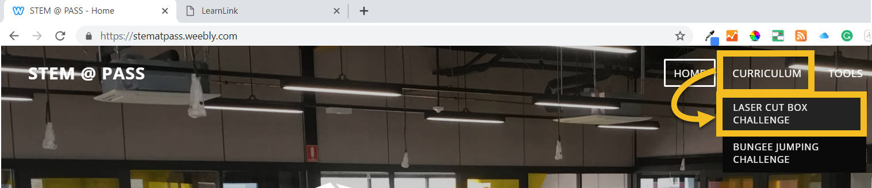

Basic Information

Collaborating Team Members
Due Date
Teacher

Below are the descriptions for the level 1, 2 and 3 versions of this task. Please tick the one you are working on.
Please note that we strongly value creativity in this task. Additional credit will be given to box designs that have innovative design features.
Level 1 | - You have completed, in sufficient detail, all aspects of this task as outlined in this booklet.  - You do not need to consider material wastage in your design and hence can ignore these parts of the booklet.
Level 2 | - You have completed, in a high level of detail, all aspects of this task as outlined in this booklet.  - The box you design should have 10% or less material wastage. This wastage does not include the wastage from the cut out “fingers” from your finger joints.  - You must have well documented calculations to support the amount of wastage in your box design.
Level 3 | - You have completed, in a very high level of detail, all aspects of this task as outlined in this booklet.  - The box you design should have 10% or less material wastage. This wastage must include the wastage from the cut out “fingers” from your finger joints.  - You must have well documented calculations to support the amount of wastage in your box design.

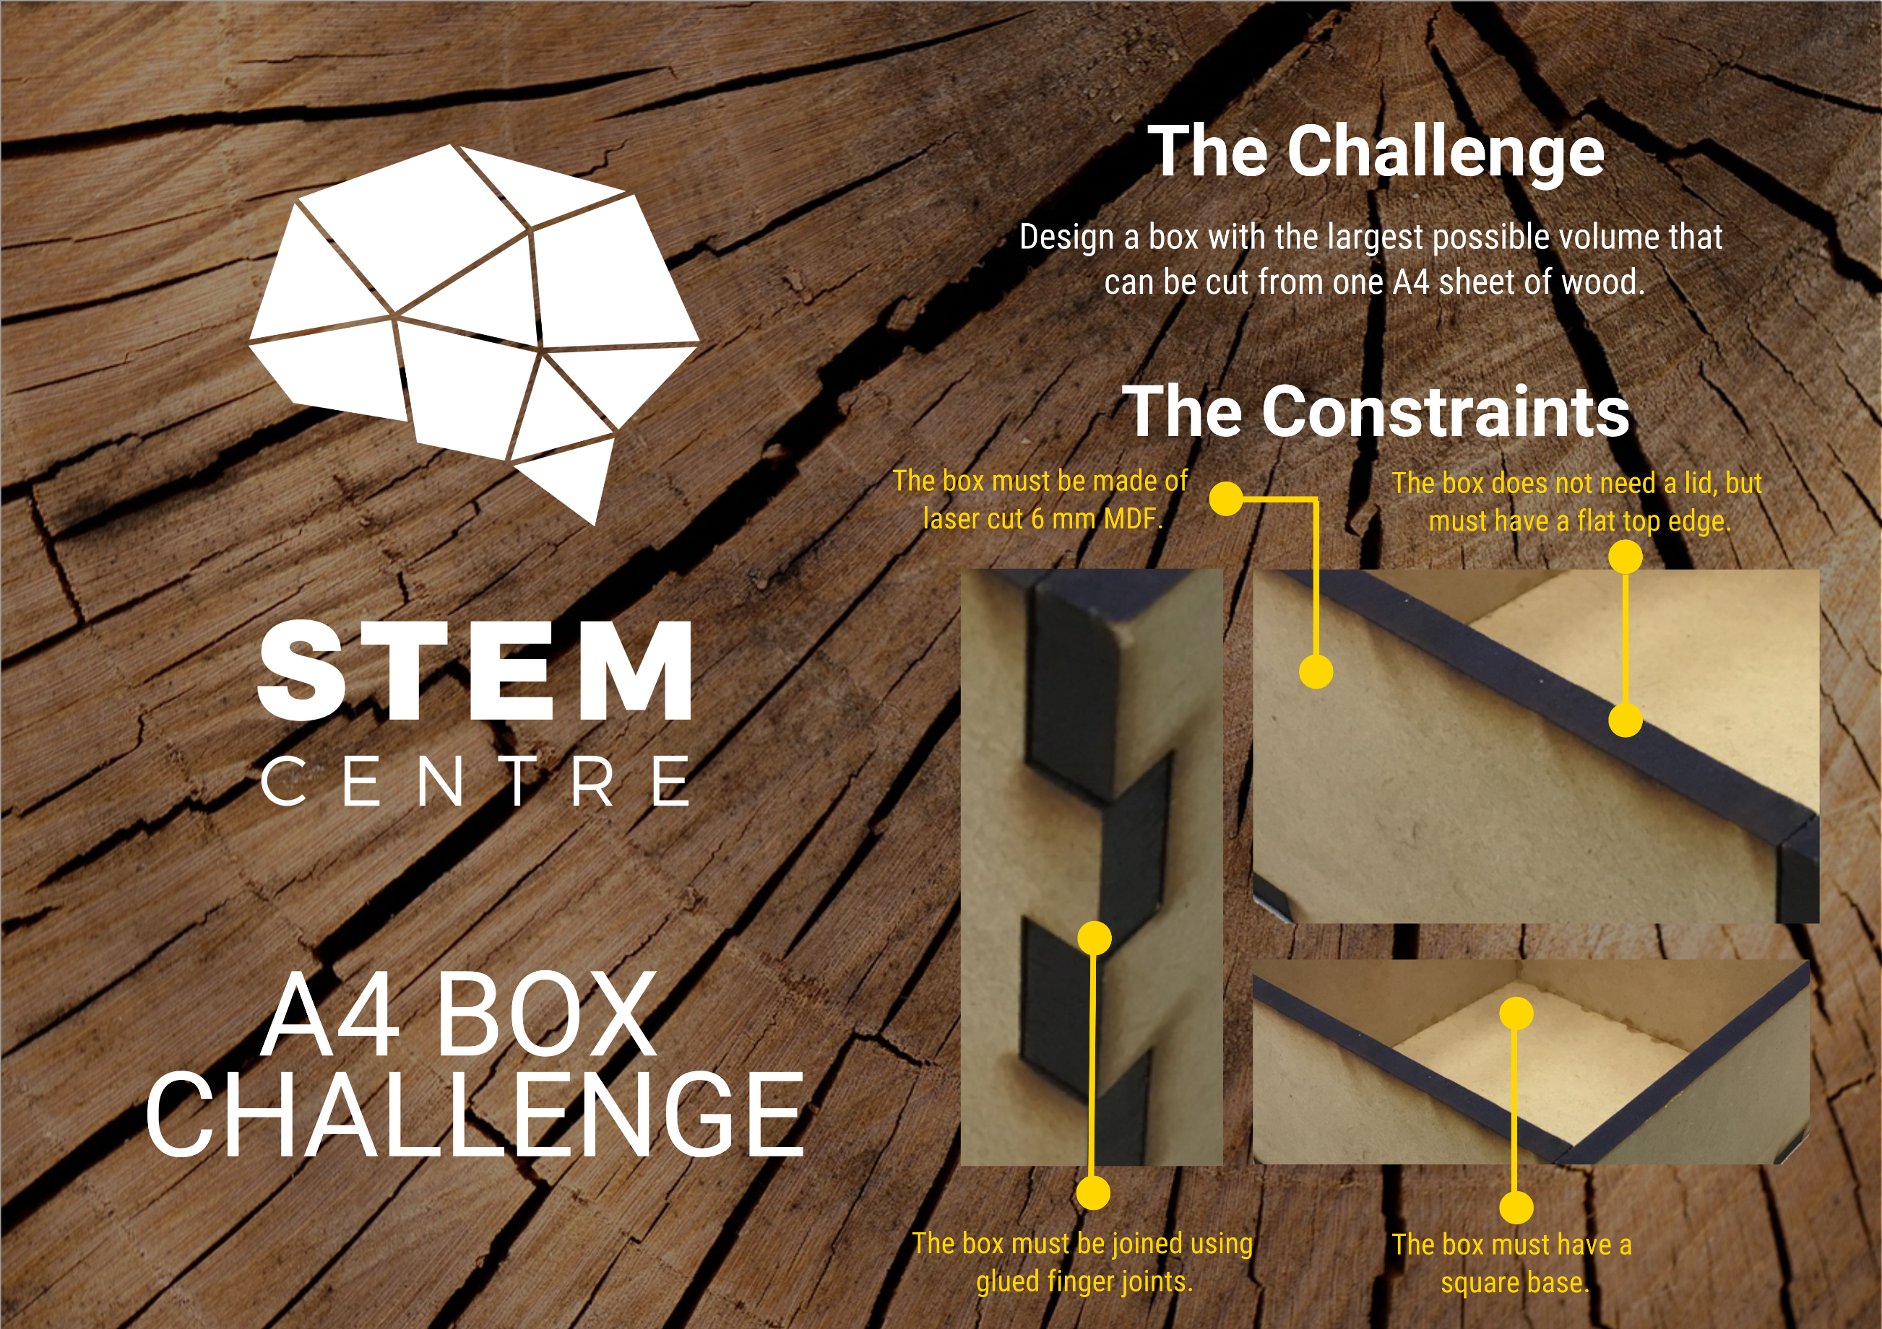
The Challenge

Project Information

Design Brief
Project Constraints
Background Research

Prototype Development

Prototype 1
Sketch and calculations
Prototype strengths and weaknesses

Prototype 2
Sketch and calculations
Prototype strengths and weaknesses

Prototype 3
Sketch and calculations

Prototype strengths and weaknesses

Final Solution Selection

Prototype chosen for construction
Justification of your choice (include any relevant mathematics)

Testing and Analysis of Volume

Internal Box Dimensions (mm)
Length | Width | Height
Internal Volume (mm²) – Show Calculation
How does your final tested volume compare to the volume you calculated for your chosen prototype? What are the reasons for any difference?

Testing and Analysis of Material Wastage
This section is only for those groups attempting the level 2 and 3 versions of the task.
Percentage of material wastage – Show Calculation
Why is it important to take material wastage into account in any design? Who/What does it impact on?
How did having to think about material wastage influence your design?

Analysis of the Designs of Others

Speak to three other groups about their total internal volume and look at the design of their box. How does the volume of your box compare to theirs and in looking at their design what are the main differences.

Group Members | Total Internal Volume | Main differences between your box and their box
Given your observations in the section above what do you feel that other people felt was most important in building a large box? In looking at the largest and smallest boxes what appears to be the most important factors to consider in building a large box?

Group Work Reflection

What were the successes of your work as a group? You may want to refer to the final page of this booklet for some inspiration of what to talk about.
What were the challenges of your work as a group? You may want to refer to the final page of this booklet for some inspiration of what to talk about.
In what ways can you improve the effectiveness of your collaboration in future tasks of this type?

Task Quality Reflection

In looking at your work on this task what parts of the task are you happiest with? What parts do you think are strong?
In looking at your work on this task what parts of the task are you least happy with? What parts do you think required more work?
What grade do you feel this task deserves and what evidence is there in your work to justify this grade?
A | B | C | D | E

Project Timeline – Gantt Chart

TASKS | Week 1 |  |  |  |  | Week 2 |  |  |  |  | Week 3 |  |  |  |  | Week 4 |  |  |  |  | Week 5
 | 1 | 2 | 3 | 4 | 5 | 1 | 2 | 3 | 4 | 5 | 1 | 2 | 3 | 4 | 5 | 1 | 2 | 3 | 4 | 5 | 1 | 2 | 3 | 4 | 5
Challenge
Introduction
Design Brief and
Project Constraints
Background
Research
Prototype
Development
Final Selection Justification and Analysis
Computer Model
Cutting and Construction
Final Testing
Testing and Analysis of Your Design and the Designs of Others
Group Work and Task Quality Reflections
Presentation
/Celebration

Characteristics of Effective Collaboration

Contribution to Process
- Actively works toward setting and meeting group goals
- Works to divide tasks equitably and fairly
- Performs duties associated with assigned roles
- Assists others who express a need for help
- Volunteers assistance to the group
- Participates in team meetings
- Is punctual and works within the timeline established by the group.
- Completes tasks and participates in discussions without needing to be reminded

Contribution to Project
- Identifies and shares new ideas
- Gathers, organizes, and shares relevant information
- Expresses opinions regarding project
- Expands the work of others
- Connects to the work of others
- Provides examples to extend the work of others
- Identifies need to edit work or change directions
- Helps other make connects or see the “big picture”
- Encourages others to contribute
- Defends contributions

Contribution to Group
- Listens to team members
- Is empathetic to the feelings of group members
- Acknowledges all viewpoints
- Speaks up to clarify peer statements
- Contributes new perspectives to the group
- Commends the good work of group members
- Offers constructive criticism of group members
- Encourages ongoing evaluation of group collaboration
- Facilitates group consensus or decision making process
- Involves all members in the group
- Promotes a positive atmosphere for group work
- Refrains from dominating discussions

Obtained from Annette Lamb at https://eduscapes.com/sessions/abc/collaboration.pdf

Spare Pages
If you need any further space to complete any of the questions use one of the following pages to do so. Make sure you clearly identify where it links in your document, this could be a question or a page number.

