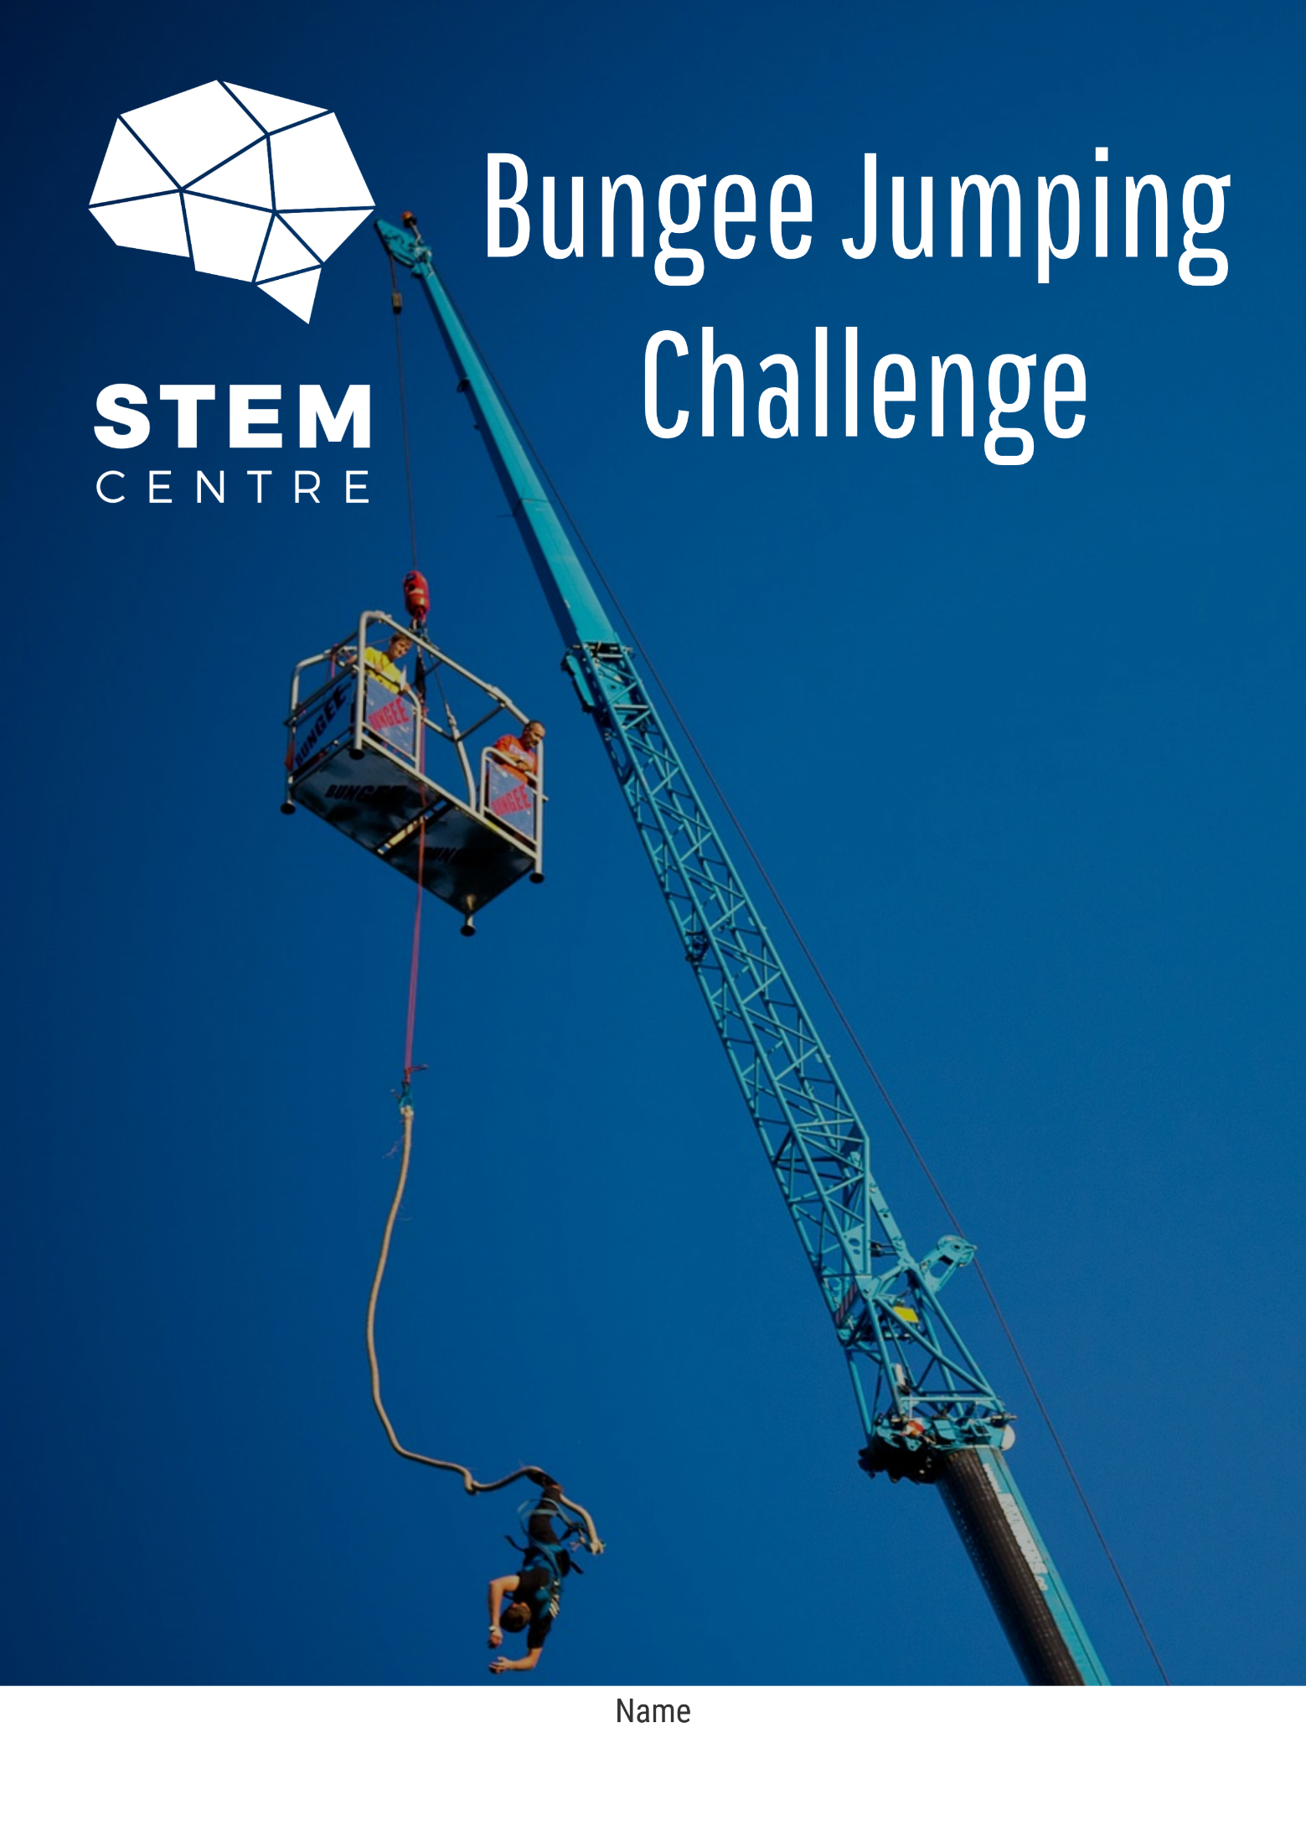­

Contents

Resources 3

Basic Information 4

The Challenge 5

Project Information 6

Initial Thinking 7

Experimental Design 8

Weight Vest Design – Level 2 and 3 Only 9

Data Analysis 10

Jump Calculator Tool 14

Final Test Recording Log 15

Investigation Reflection Questions 17

Group Work Reflection 18

Task Quality Reflection 19

Project Timeline – Gantt Chart 20

Characteristics of Effective Collaboration 21

Spare Pages 22

# Resources

Additional resources to help with the completion of this task can be found at the Port Augusta Secondary School STEM centre website. This includes instructional videos on various parts of the task and also links to download the CAD software and also digital maths tools for making your jump calculator tool.

<http://stematpass.weebly.com>

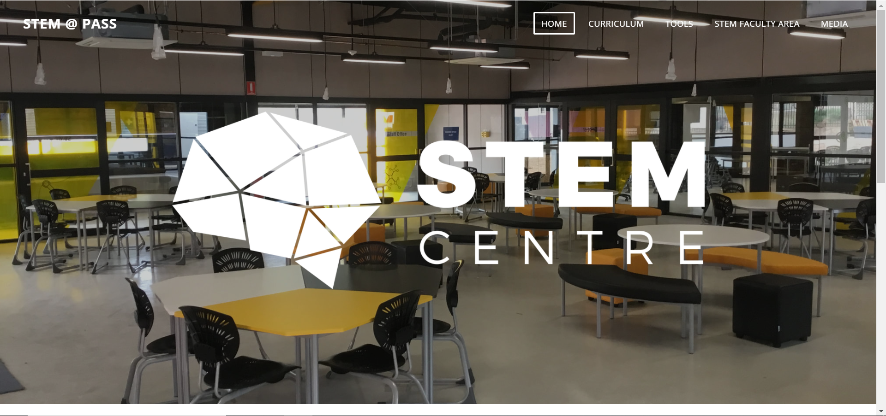

The link to the resources is under curriculum and then Bungee Jumping Challenge.

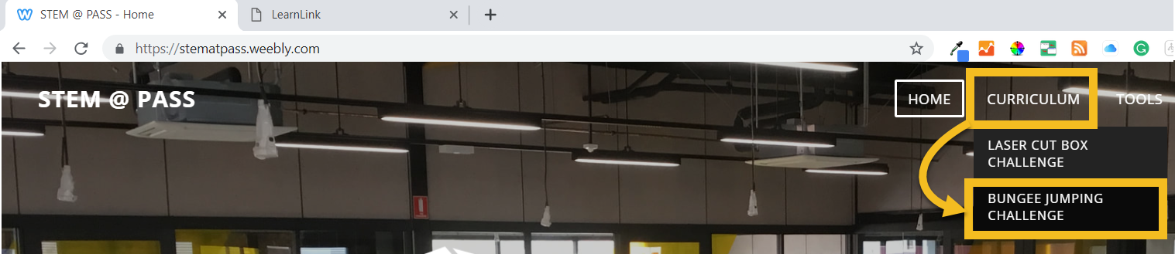

# Basic Information

|  |  |
| --- | --- |
| **Collaborating Team Members** |  |
| **Due Date** |  |
| **Teacher** |  |

|  |  |  |
| --- | --- | --- |
| **Below are the descriptions for the level 1, 2 and 3 versions of this task. Please tick the one you are working on.** | | |
| **Level 1** | * In this version of the task you do not need to consider weight. * All you will be investigating is the relationship between the number of rubber bands and the drop distance for your chosen bungee jumping doll. * The sections dealing with the weight harness design can be ignored. |  |
| **Level 2** | * In this version of the task you will be considering weight in your calculations, however the weights you investigate will be limited. * On jump day you will use your chosen bungee jumping doll and either 0, 4 or 8 washers will be added to the weight. * You will need to factor the weight harness design and printing into your timing. |  |
| **Level 3** | * In this version of the task you will be considering weight in your calculations. * On the day of the final testing both the bungee jumping doll you use and the number of washers added, will be chosen at random. * Hence your mathematical model will need to be flexible enough to deal with any situation. * You will need to factor the weight harness design and printing into your timing |  |

# C:\Users\loaders\Desktop\26954c7a-2755-4d89-9a87-72e66fb9f7ed (1).pngThe Challenge

# Project Information

|  |
| --- |
| **Design Brief** |
|  |
| **Project Constraints** |
|  |

# Initial Thinking

|  |
| --- |
| **In the final test they want to see a “safe but very thrilling jump”, what would you expect to see happen if the jump was to meet these criteria** |
|  |
| **In the final test the height they are jumping from and for some the final weight of the jumper, will not be known until the day. How might you gather information prior to the day to inform your decision of how many bungee sections to use in the final test?** |
|  |
| **The company wants an easy to use tool for employees to use so that they can quickly and accurately determine the number of sections needed, this is the same tool you will use on jump day. What sorts of mathematical, technological or other tools may make this a quick and easy task?** |
|  |

# Experimental Design

Below is some space for you to design your experiment to collect data. If you make any changes to your materials or your procedure along the way then please document this in a different colour, but leave the original here.

|  |  |  |
| --- | --- | --- |
| **Materials Supplied** | | **Other Materials Required** |
| * Bungee Jumping Doll * Rubber bands x 11 * Metre ruler   + - Masking Tape | **Level 2 and 3 only**   * 10 x washers * 2 x paper clips/wire * 3D printer * Electronic Scale * Vernier Callipers |  |
| **Procedure** | | |
| In the space below write a procedure for how you will conduct your tests to collect the data that you need. | | |

# Weight Vest Design – Level 2 and 3 Only

|  |  |  |  |
| --- | --- | --- | --- |
| **Initial Measurements** | | | |
| C:\Users\loaders\AppData\Local\Temp\SNAGHTML46a6960.PNG |  | |  |
| **Description** | **Measurement**  **(mm)** |  |
| **Top to bottom** |  |  |
| **Left to right** |  |  |
| **Front to back** |  |  |
| **Leg gap** |  |  |
|  | |  |
| **Description** | **Measurement**  **(mm)** |  |
| **Thickness** |  |  |
| **Inside Diameter** |  |  |
| **Washer Width** |  |  |
|  | |  |

# Data Analysis

|  |
| --- |
| **Experimental Data Collected** |
|  |
|  |
| **Data Displays and Mathematical Models** |
|  |
|  |

# Jump Calculator Tool

Use the tool below to calculate the number of bungee sections needed for any jump height (up to 8 metres) or jumper weight (up to 200 g). This must fit on this page or must be an easily used electronic tool

# Final Test Recording Log

|  |  |  |  |
| --- | --- | --- | --- |
| **Jump Conditions** | | | |
| Jump Location |  | | |
| Jump Height |  | Jumper Weight |  |

|  |  |  |  |  |  |
| --- | --- | --- | --- | --- | --- |
| **Jump Attempt 1** | | | | | |
| Number of Bungee Cord Sections |  | Was the Jump Safe? | Yes / No | Approximate Distance from Ground |  |
| How you decided on the number of bungee sections |  | | | | |
| Successful aspects of the jump |  | | | | |
| Aspects of the jump that could be improved |  | | | | |
| Changes you will make for the next attempt |  | | | | |
| **Jump Attempt 2** | | | | | |
| Number of Bungee Cord Sections |  | Was the Jump Successful? | Yes / No | Approximate Distance from Ground |  |
| How you decided on the number of bungee sections |  | | | | |
| Successful aspects of the jump |  | | | | |
| Aspects of the jump that could be improved |  | | | | |
| Changes you will make for the next attempt |  | | | | |

|  |  |  |  |  |  |
| --- | --- | --- | --- | --- | --- |
| **Jump Attempt 3** | | | | | |
| Number of Bungee Cord Sections |  | Was the Jump Successful? | Yes / No | Approximate Distance from Ground |  |
| How you decided on the number of bungee sections |  | | | | |
| Successful aspects of the jump |  | | | | |
| Aspects of the jump that could be improved |  | | | | |
| Changes you would have made for the next attempt |  | | | | |

# Investigation Reflection Questions

|  |
| --- |
| **How successful do you feel your mathematical model was in meeting the requirements of this task? This includes reflecting on giving the jumper a safe but thrilling ride and providing an easy to use tool for bungee staff to calculate the correct number of sections.** |
|  |
| **In what ways would you improve your mathematical model and/or the experiment that led to that mathematical model to ensure greater accuracy of your model if you were to complete this task again.** |
|  |
| **This unit has been done as part of your work on algebra, particularly in relation to linear relationships. Explain the connections you have been able to find between this activity and the work on linear relationships** |
|  |

# Group Work Reflection

|  |
| --- |
| **What were the successes of your work as a group.? You may want to refer to the final page of this booklet for some inspiration of what to talk about.** |
|  |
| **What were the challenges of your work as a group.? You may want to refer to the final page of this booklet for some inspiration of what to talk about.** |
|  |
| **In what ways can you improve the effectiveness of your collaboration in future tasks of this type?** |
|  |

# Task Quality Reflection

|  |  |  |  |  |
| --- | --- | --- | --- | --- |
| **In looking at your work on this task what parts of the task are you happiest with? What parts do you think are strong?** | | | | |
|  | | | | |
| **In looking at your work on this task what parts of the task are you least happy with? What parts do you think required more work?** | | | | |
|  | | | | |
| **What grade do you feel this task deserves and what evidence is there in your work to justify this grade?** | | | | |
| **A** | **B** | **C** | **D** | **E** |
|  | | | | |

# Project Timeline – Gantt Chart

|  |  |  |  |  |  |  |  |  |  |  |  |  |  |  |  |  |  |  |  |  |  |  |  |  |  |
| --- | --- | --- | --- | --- | --- | --- | --- | --- | --- | --- | --- | --- | --- | --- | --- | --- | --- | --- | --- | --- | --- | --- | --- | --- | --- |
| TASKS | Week 1 | | | | | Week 2 | | | | | Week 3 | | | | | Week 4 | | | | | Week 5 | | | | |
| 1 | 2 | 3 | 4 | 5 | 1 | 2 | 3 | 4 | 5 | 1 | 2 | 3 | 4 | 5 | 1 | 2 | 3 | 4 | 5 | 1 | 2 | 3 | 4 | 5 |
| Project Introduction |  |  |  |  |  |  |  |  |  |  |  |  |  |  |  |  |  |  |  |  |  |  |  |  |  |
| Project Information |  |  |  |  |  |  |  |  |  |  |  |  |  |  |  |  |  |  |  |  |  |  |  |  |  |
| Initial Thinking |  |  |  |  |  |  |  |  |  |  |  |  |  |  |  |  |  |  |  |  |  |  |  |  |  |
| Experimental Design |  |  |  |  |  |  |  |  |  |  |  |  |  |  |  |  |  |  |  |  |  |  |  |  |  |
| **Weight Vest Design and Printing**  **(level 2 and 3 only)** |  |  |  |  |  |  |  |  |  |  |  |  |  |  |  |  |  |  |  |  |  |  |  |  |  |
| Data Collection  and Analysis |  |  |  |  |  |  |  |  |  |  |  |  |  |  |  |  |  |  |  |  |  |  |  |  |  |
| Jump Calculator Tool Development and Presentation |  |  |  |  |  |  |  |  |  |  |  |  |  |  |  |  |  |  |  |  |  |  |  |  |  |
| Final Testing |  |  |  |  |  |  |  |  |  |  |  |  |  |  |  |  |  |  |  |  |  |  |  |  |  |
| Reflection |  |  |  |  |  |  |  |  |  |  |  |  |  |  |  |  |  |  |  |  |  |  |  |  |  |
| Finalise and Celebrate |  |  |  |  |  |  |  |  |  |  |  |  |  |  |  |  |  |  |  |  |  |  |  |  |  |

# Characteristics of Effective Collaboration

Contribution to Process

* Actively works toward setting and meeting group goals
* Works to divide tasks equitably and fairly
* Performs duties associated with assigned roles
* Assists others who express a need for help
* Volunteers assistance to the group
* Participates in team meetings
* Is punctual and works within the timeline established by the group.
* Completes tasks and participates in discussions without needing to be reminded

Contribution to Project

* Identifies and shares new ideas
* Gathers, organizes, and shares relevant information
* Expresses opinions regarding project
* Expands the work of others
* Connects to the work of others
* Provides examples to extend the work of others
* Identifies need to edit work or change directions
* Helps other make connects or see the “big picture”
* Encourages others to contribute
* Defends contributions

Contribution to Group

* Listens to team members
* Is empathetic to the feelings of group members
* Acknowledges all viewpoints
* Speaks up to clarify peer statements
* Contributes new perspectives to the group
* Commends the good work of group members
* Offers constructive criticism of group members
* Encourages ongoing evaluation of group collaboration
* Facilitates group consensus or decision making process
* Involves all members in the group
* Promotes a positive atmosphere for group work
* Refrains from dominating discussions

Obtained from Annette Lamb at <https://eduscapes.com/sessions/abc/collaboration.pdf>

# Spare Pages

If you need any further space to complete any of the questions use one of the following pages to do so. Make sure you clearly identify where it links in your document, this could be a question or a page number.

