Student Workbook
Your Name

How can STEM skills help us to design better games?
Game Master
Contents

Important Information 3
Tinkercad Keyboard Shortcuts 4
Board Game INformation and Constraints 5
Project Timeline 6
Game Analysis 7
Individual Brainstorming 11
Collaborative Brainstorming 13
Concept Development 14
Prototype Development 21
Prototype Testing 23
Pitch 24
Build 25
Evaluation 29
Peer Evaluation 29
Self-evaluation 30

Important Information

Below is a list of important information that you will need to refer to as you complete this task, it is links to websites, login details, keyboard shortcuts etc.

STEM Centre Website | www.stematpass.weebly.com
Tinkercad  Login Link | www.tinkercad.com/joinclass/
Class Code
Nickname
(your student ID number)

Acknowledgement
This unit of work is inspired by, and some of the tasks base on the work of the Shell Centre for Mathematical Education. A link to this unit of work can be found below
https://www.mathshell.com/materials.php?series=numeracy&item=boardgame

Tinkercad Keyboard Shortcuts

This information sheet will provide you with some keyboard shortcuts to help you when using Tinkercad.

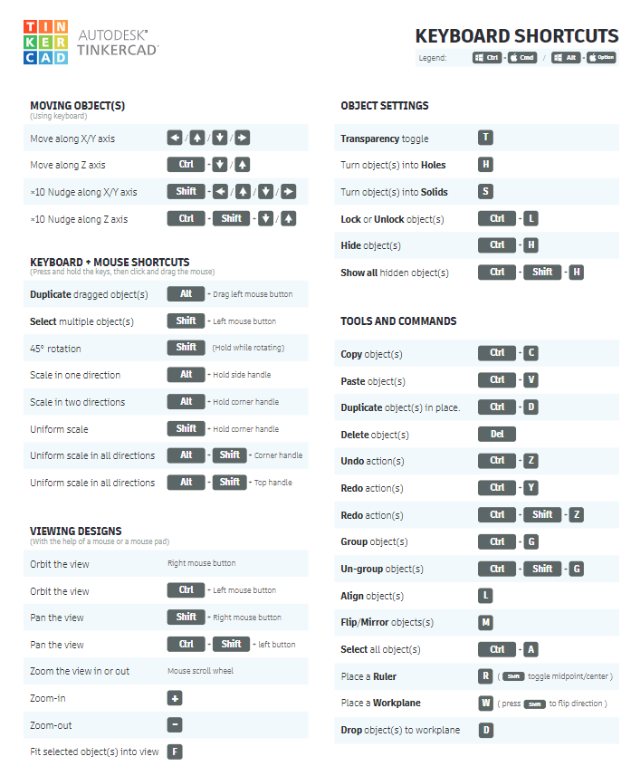

Board Game INformation and Constraints
Evidence of board games has been around since 3500 BC, they are a popular past time for many people. In this unit of work you will produce your own board game as a small group. This game will be designed using some of the technology in the STEM Centre including 3D printers, the laser cutter, and soldering equipment. This game will be played and evaluated by both you, and your peers.

Your design must meet the following project constraints.
Prerequisites | - All preliminary research and planning tasks must be completed before building
Time | - You will be given a maximum of 4 weeks to complete the final build this includes  - Computer Aided Design  - Fabrication of parts (laser cutting, 3D printing, soldering)  - Assembly of the final product
Roles | - You will work in either in pairs or groups of 3 to complete this task.  - If working in pairs a board and game pieces must be produced.  - If working in a group of 3, the game must also include some electronics, cards, etc.  - Each person should take responsibility for one part (e.g. board, movers etc).
Design | - All game pieces must be designed, none can be prefabricated (e.g. dice).  - All parts for the game must be originally designed by your group and not taken from online.  - Tinkercad will be the default software for designing all parts of the game. You may use other programs, but these must already be familiar to you.
Production Methods | - The board will be laser cut, the game pieces will be 3D printed, and the electronics will be soldered.  - All parts for the game must be digitally produced, no hand drawing or painting, etc will be allowed.
Size | - The board will be a maximum of A3 size (420 x 297 mm).  - Game pieces must be designed to the correct size (no rescaling allowed)
Materials | - The main body of the game board will be MDF, with decorations in acrylic  - The game pieces will be made of PLA plastic  - Electronic components are limited to small nails and aluminium discs (for contact switches, LED’s (lights), small motors, buzzers, wires and 2 x AA batteries  - Adhesives available will be PVA (wood glue), hot glue, super glue Week

Project Timeline

Below is a rough timeline for the expected time for each part of the project. You may take longer in some parts, and shorter than others.

 |  | Introduction | Game Analysis | Individual Brainstorming | Collaborative Brainstorming | Concept Development | Prototype Development | Prototype Testing | Build | Evaluation
Week 1 | 1
 | 2
 | 3
 | 4
 | 5
Week 2 | 1
 | 2
 | 3
 | 4
 | 5
Week 3 | 1
 | 2
 | 3
 | 4
 | 5
Week 4 | 1
 | 2
 | 3
 | 4
 | 5
Week 5 | 1
 | 2
 | 3
 | 4
 | 5
Week 6 | 1
 | 2
 | 3
 | 4
 | 5
Week 7 | 1
 | 2
 | 3
 | 4
 | 5
Week 8 | 1
 | 2
 | 3
 | 4
 | 5
Week 9 | 1
 | 2
 | 3
 | 4
 | 5

Game Analysis

Name of Game | The Great Horse Race

What works well | What doesn’t work well
How you would improve the game

Game Data
 | 1 | 2 | 3 | 4 | 5 | 6 | 7 | 8 | 9 | 10 | Average
Game Length (min)
Winning Character

Name of Game | Bugs

What works well | What doesn’t work well
How you would improve the game

Game Data
 | 1 | 2 | 3 | 4 | 5 | 6 | 7 | 8 | 9 | 10 | Average
Game Length (min)
Winning Character

Name of Game | Goal

What works well | What doesn’t work well
How you would improve the game

Game Data
 | 1 | 2 | 3 | 4 | 5 | 6 | 7 | 8 | 9 | 10 | Average
Game Length (min)
Winning Character

Name of Game | Honeycomb

What works well | What doesn’t work well
How you would improve the game

Game Data
 | 1 | 2 | 3 | 4 | 5 | 6 | 7 | 8 | 9 | 10 | Average
Game Length (min)
Winning Character

Individual Brainstorming

What Theme might the Game Have?
A good board game, like any good story, has a theme. It has a setting in which all the action occurs. Some examples of this may include “a buried treasure” or “a day at the beach”. Use the space below to list some possible themes for your board game, you should have at least six themes identified (not including the ones stated here).

What might be the Aim of the Game?
When looking at designing a game it is important to determine the aim of the game. This lets the players know what they should be trying to do to win. The aim can take several different forms such as “scoring the most points” or “getting to the end first”. Use the space below to suggest at least three different aims (not including the ones stated here) that could be used with a game you design.

What Could be Some Special Features?
Special features are those parts of the game that really make it stand out from others. The special features can take several different forms such as “spinner instead of dice” or “cards that you pick up”. Use the space below to suggest at least three different special features (not including the ones stated here) that could be used with a game you design.

What might the board look like?
The board is the centrepiece of any board game, and should provide a visually interesting, and engaging experience for the players. Some examples of board game shapes are shown below, but there are many more possibilities that exist. In the space below draw, or include images for at least three different boards that you feel would be good for a board game (not including the ones shown below).

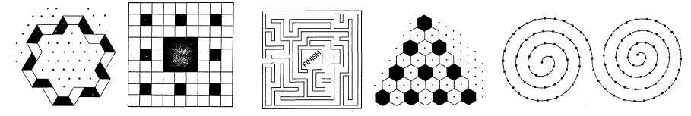

Collaborative Brainstorming

The space below should be a record of your brainstorming process as a group. You should all be given time to share your ideas before deciding on which way you may go

 | Person 1 - | Person 2 -
An idea for a theme that I liked
An idea for an aim that I liked
An idea for a special feature that I liked
Other discussions

Concept Development

Name of the game

Who plays the game (number of players, ages, etc) | What you need in order to play (e.g. dice, cards, etc)
What it is about (what is the theme or back story) | Aims of the game (how do you win)

Rules
How to start
How to make a move
Other rules

Board Design

Prototype Development

There is space below to make notes while you are developing your prototype, this should include drawings, photos, work completed, difficulties faced and decisions made. Make sure you keep in mind how you will meet all of the constraints for the task.

Prototype Testing

In the space below you will test your game by playing it several times (up to 10), you will only be playing it with members of your own group. When playing it make sure you are doing so with a critical eye, the aim of this process is to look for what works well and what needs to improve.

Game Data
 | 1 | 2 | 3 | 4 | 5 | 6 | 7 | 8 | 9 | 10 | Average
Game Length (min)
Winning Character

What about the game works well?
What about the game needs improvement? What changes will you make in the final game?

Build

Use the space below to document your build process by adding photo, sketches and notes about what you did, problems you faced, decisions you made etc

Week 1
Week 2
Week 3
Week 4

Evaluation

Peer Evaluation

Use the spaces provided below to summarised the information gained from the peer review process. Table below write how many of each response (1 to 5) you received for your game and then calculate the average score.
 | 1 | 2 | 3 | 4 | 5 | Average
The game was fun / interesting
It was easy to follow the rules
The board and game pieces were well designed
The game appears to be fair

Use the spaces below to summarise the information gained from the peer review process
These are the things that people liked about the game
These are the things that people didn’t like about the game
These are the improvements that people suggested

Self-evaluation
Use the spaces below to reflect on your game and your learning in this task
Reflecting on the Game
If I was going to improve the rules, I would change them in the following ways.
If I was going to improve the board and other components, I would change them in the following ways.
Reflecting on your work as a group
 | Myself |  |  |  |  | Others
 | 1 | 2 | 3 | 4 | 5 | 1 | 2 | 3 | 4 | 5
Group members were completing their set tasks in the set time
Tasks were assigned fairly and based on people’s strengths
Progress was monitored
Support and productive feedback were given to the group
Ideas and opinions were shared with the group
The ideas of others were valued
These are the ways that I was a good team member
These are the ways I could have been a better team member
These are the ways we worked well as a group
These are the things we could have done to work better as a group
Reflecting on your Learning
The areas I felt confident and successful in were
The areas I did not feel confident or comfortable with were
The new skills that I have learned are
The skills I feel I still need to develop are
If I was doing a task like this in the future, these are the changes I would need to make to how I approach it

